Advanced Data Visualization with Tableau

# Installation of Tableau

1- Enter this URL  <https://www.tableau.com/products/desktop> on your web browser.

2- Click on the “TRY NOW” button in the top-right corner of the website as shown below.

3- Once you click on the “TRY NOW” button, you will be redirected to a page that will ask you to feed in your official email address. After filling in the email address, click on the “DOWNLOAD FREE TRIAL” button.

4- The latest version of Tableau Desktop will start downloading, and you will be able to view the download progress in the bottom-left corner of the screen.

5- Once downloaded, open the file. Accept the terms and conditions, and click on the “Install” button.

6- A pop-up option will appear asking for the approval of the administrator to install the software. Click on “YES” to approve and move further.

7- On approval, the installation will start. On the completion of the installation, open Tableau.

8- This is the final stage that asks for registration. Click on “Activate Tableau” and enter your license details or credentials.

9- Click on “Start Trial Now” and wait for the registration process to complete.

10- Once it is completed, open the Tableau screen to do your useful visualizations.

# Dataset - Telangana Weather Data December-2022

Metadata-

'District': Name of the district,

'Mandal': Name of the Mandal,

'Date': Date in yyyy-mm-dd format,

'Rainfall (mm)': Cumulative Rainfall in mm,

'temp_min (⁰C)': Minimum Temperature in Celsius,

'temp_max (⁰C)': Maximum Temperature in Celsius,

'humidity_min (%)': Minimum Humidity %,

'humidity_max (%)': Maximum Humidity %,

'wind_speed_min (Kmph)': Minimum Wind Speed in kmph,

'wind_speed_max (Kmph)': Maximum Wind Speed in kmph.

## Bar Chart:

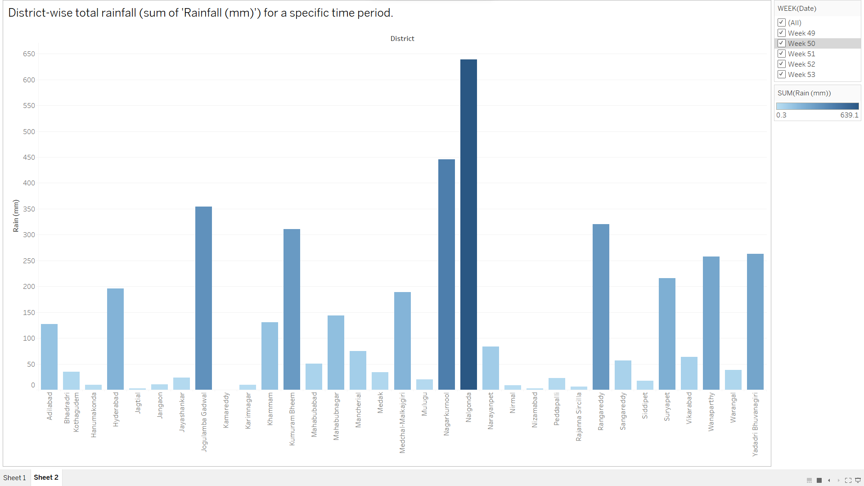

This visualization shows the cumulative rainfall in millimeters for each district or mandal over a specific time period, allowing for a comparative analysis of the total rainfall in different regions.

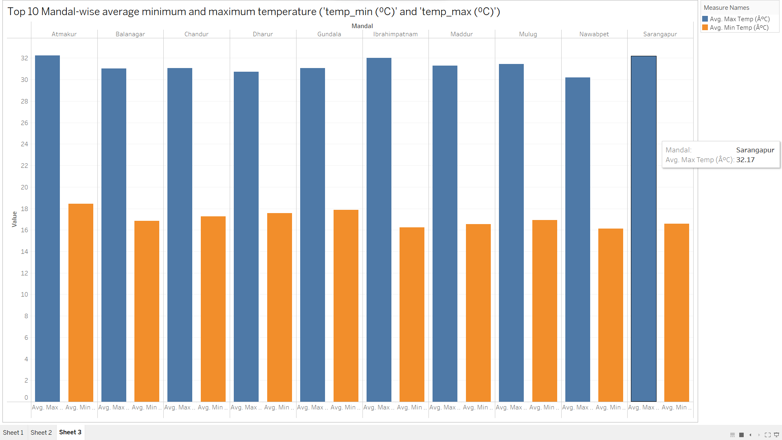

This visualization presents the top 10 mandals ranked by their average minimum and maximum temperatures (temp_min and temp_max in ⁰C), allowing for an insight into the regions with the highest temperature range.

## Line Chart

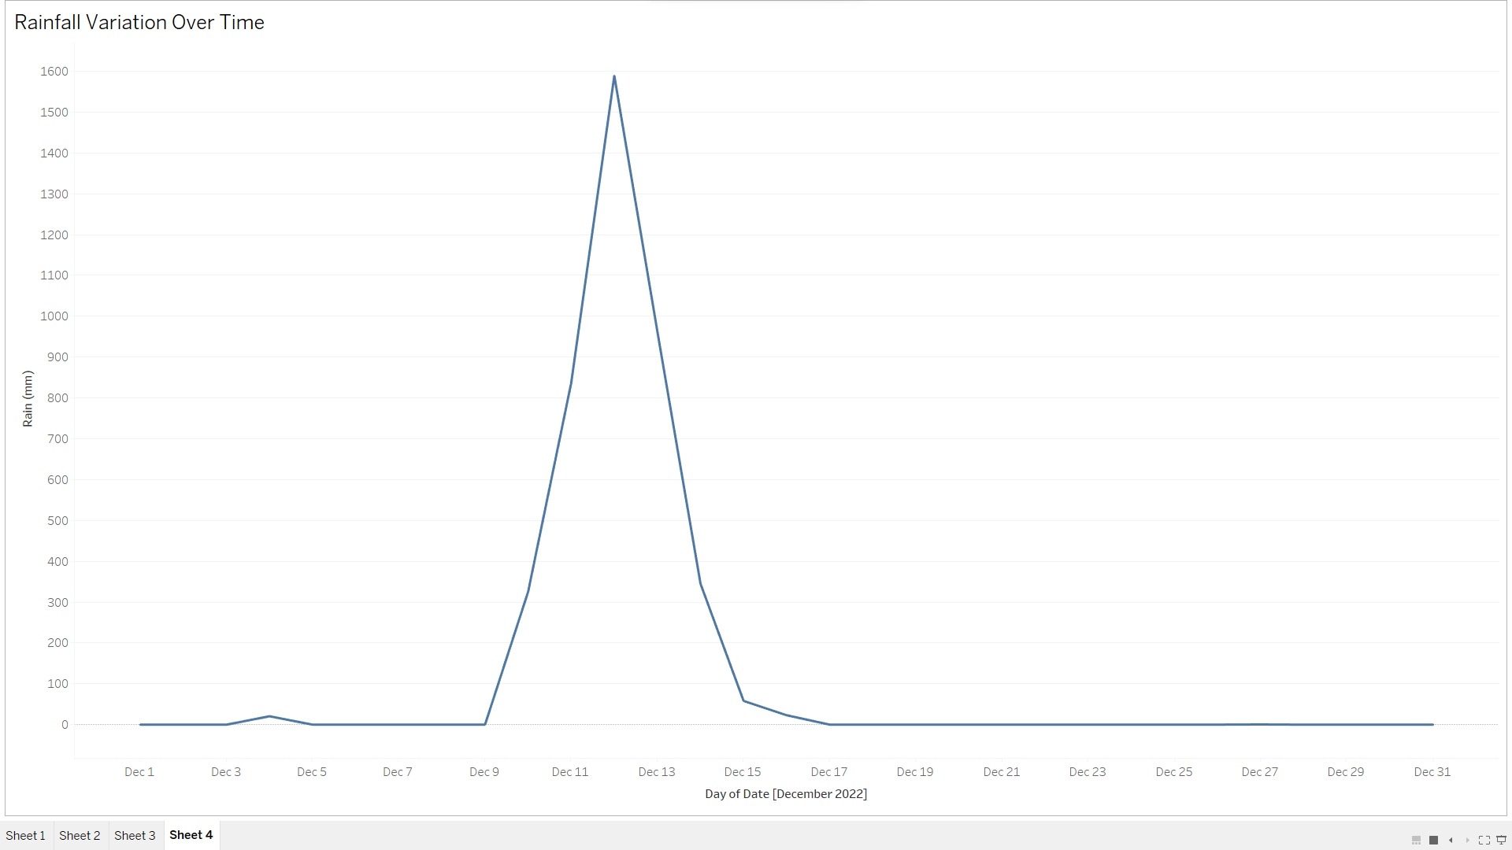

This visualization depicts the variation of rainfall over time, providing insights into the changing precipitation patterns.

## 

This visualization illustrates the trends of minimum and maximum temperature fluctuations over time, offering insights into the temperature variations across the selected period.

## Scatter plot:

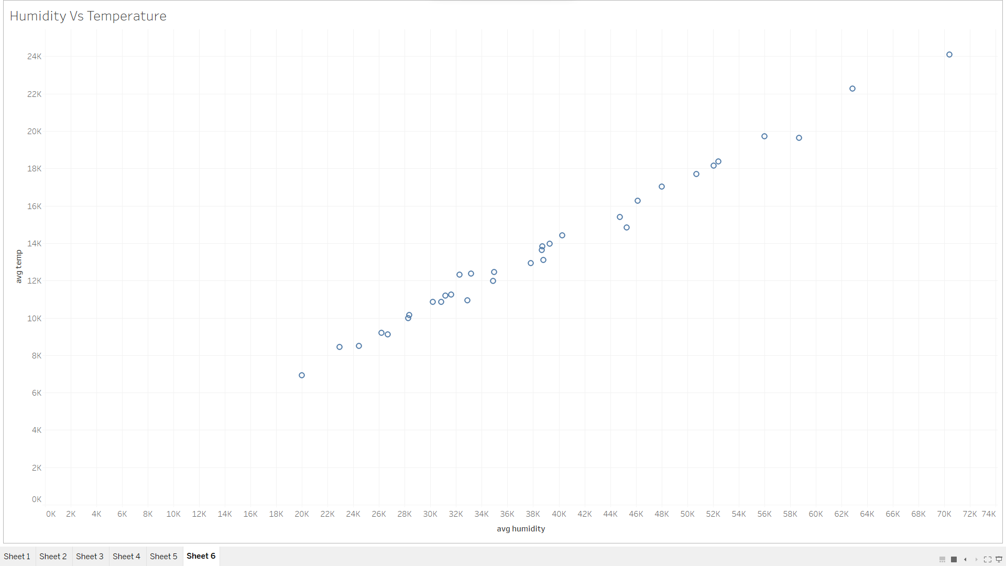

This scatter plot will help visualize the relationship between humidity and temperature in each district combination.

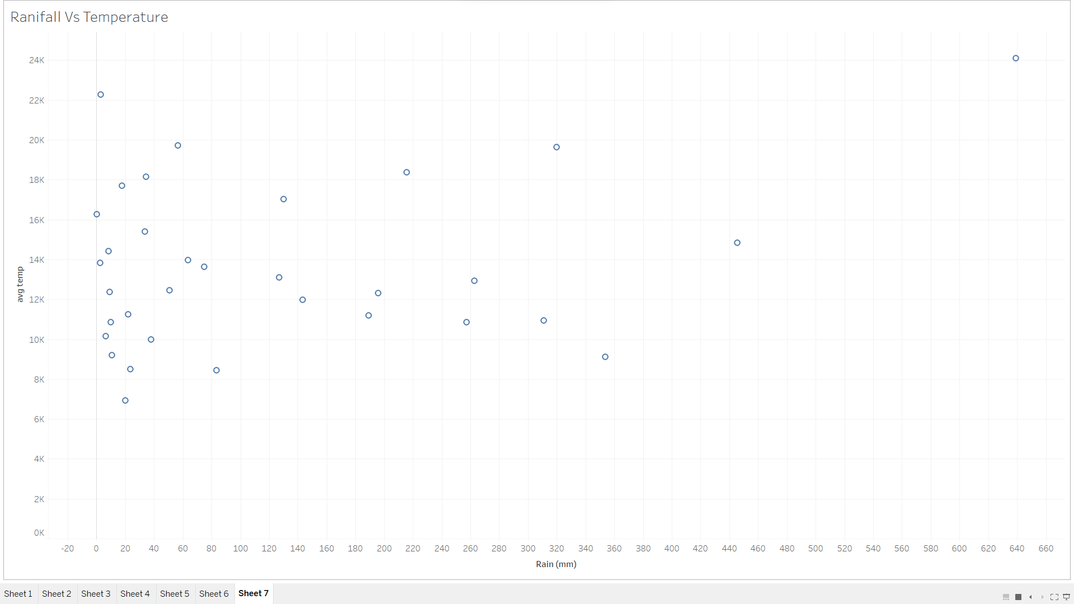

This scatter plot will show how the average temperature relates to the amount of rainfall. Each point represents a district combination.

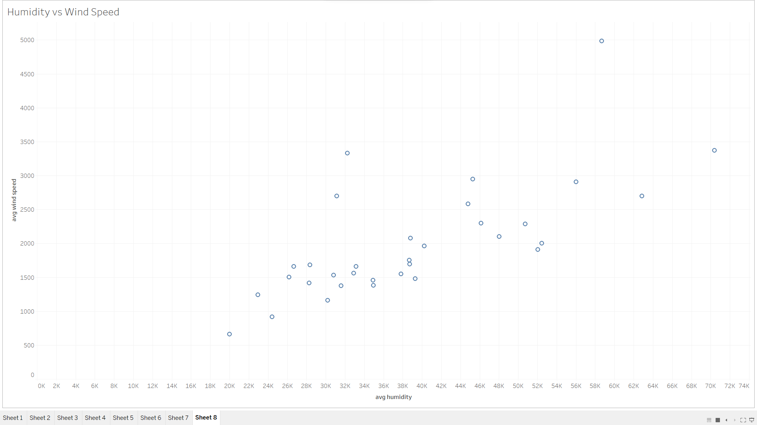

This scatter plot will show how the average humidity relates to the average wind speed. Each point represents a district-mandal combination.